Name
Class
Class no.
Date
Marks | / 50
Carmel Holy Word Secondary School
2024-2025 Term 2
Secondary 3 Computer Literacy
Practical Assessment
Time: 45 Minutes

- Write your Name, Class and Class Number in the boxes provided.
- Follow the instructions below to complete the examination tasks.
- If you fail to upload your work, NO MARK will be given.

- ALL TASKS should be finished in VS Code.
- Login to Teams and open the assignments named “S3 Term 2 Practical Assessment – Task 1”, “S3 Term 2 Practical Assessment – Task 2”, “S3 Term 2 Practical Assessment – Task 3” and “S3 Term 2 Practical Assessment – Task 4”.
- Download the files “task2_2425.py”, “task3_2425.py” and “task4_2425.py” to your computer.
- Submit your work to the appropriate assignments in Teams.

Task 1 (10 marks)
Write a program to calculate and display the Body Mass Index (BMI), as shown in Figure 1 for Task 1.
(a) Create a Python file in VS Code and name it “task1_2425.py”.
- Ask the user to input their weight in kilograms.
- Ask the user to input their height in meters.
- Calculate the BMI using the formula: BMI = weight / (height ** 2).
- Print the calculated BMI. (as shown in Figure 1).
- Save the file as “task1_2425.py” and submit it to Teams.

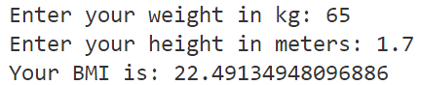

Figure 1

Task 2 (10 marks)
Write a program to input multiple math scores and calculate the highest, lowest, and average scores, as shown in Figure 2 for Task 2.
(a) Download “task2_2425.py” from Teams and open it in VS Code.
(b) Create an empty list to store the scores.
(c) Ask the user to input math scores.
(d) Convert the input string into an integer.
(e) Complete the if-elif-else condition.
- If the input number is -1, stop the loop
- If the input number is greater than 0, add the number to the list
- If the input number is neither -1 nor greater than 0, print out the number and inform the user that the number is lower than 0 (as shown in Figure 2).
(f) Print the highest score, lowest score, and average score. (As Figure 2 has shown).
(g) Save the file as “task2_2425.py” and submit it to Teams

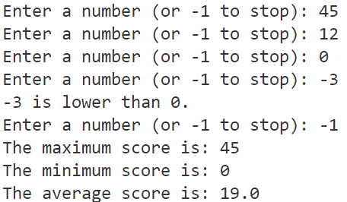

Figure 2

Task 3 (15 marks)
Write a program to convert text to speech, as shown in Figure 3 for Task 3.
(a) Download “task3_2425.py” from Teams and open it in VS Code.
(b) Import the Text-to-Speech and playsound libraries.
(c) Set up the text-to-speech engine.
(d) Ask the user for a sentence to convert to speech.
(e) Save the audio output as an mp3 file.
(f) Play the mp3 file.
(g) Print a confirmation message after saving.
(h) Save the file as “task3_2425.py” and submit it to Teams.

Figure 3

Task 4 (15 marks)
Write a program to read a video and detect faces, as shown in Figure 4 for Task 4.
(a) Download “task4_2425.py” from Teams and open it in VS Code.
(b) Import the OpenCV library
(c) Open the video file “video.mp4”.
(d) Read frames from the video.
(e) Convert the frame to grayscale
(f) Use a rectangle to mark detected faces in each frame.
(g) Display the video with marked faces.
(h) Save the file as “task4_2425.py” and submit it to Teams.

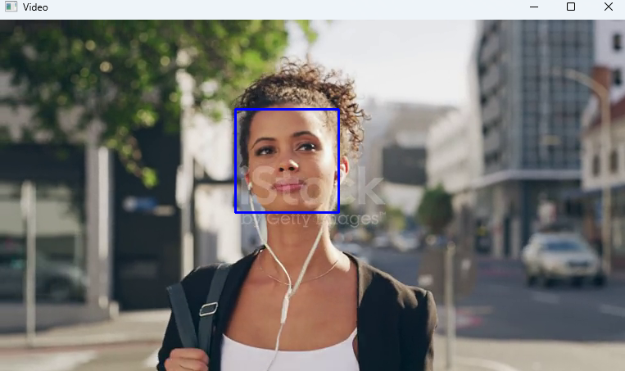
Figure 4

End of Paper

Appendix: Modules and Functions API Reference Table
Module | pip install | Example of Import Statement
gTTS | gTTS | from gtts import gTTS
Playsound | playsound==1.2.2 | from playsound import playsound
Google Cloud Translate | google-cloud-translate==2.0.1 | from google.cloud import translate_v2 as translate
Speech Recognition | SpeechRecognition | import speech_recognition as sr
OpenCV | opencv-contrib-python | import cv2

Module | Description | Function Example
gTTS | Setup gTTS | audio = gTTS(text="I Love You", lang="en")
gTTS | Save TTS audio to a file | audio.save("audio.mp3")
Playsound | Play the audio file | playsound("audio.mp3")
Google Cloud Translate | Initialize the translation client | client = translate.Client()
Google Cloud Translate | Translate text between languages | result = client.translate(text, source_language="en", target_language="zh")  print(result["translatedText"])
OpenCV | Read an image file | image = cv2.imread("face.jpg")
OpenCV | Open a video file or camera stream | cap = cv2.VideoCapture("video.mp4")
OpenCV | Read a frame from the video | isTrue, frame = cap.read()
OpenCV | Convert the frame to grayscale | cv2.cvtColor(frame, cv2.COLOR_BGR2GRAY)
OpenCV | Draw a rectangle around detected faces | cv2.rectangle(frame, (x, y), (x + w, y + h), (255, 0, 0), 2)
OpenCV | Display the video frame in a window | cv2.imshow('Video', frame)
OpenCV | Wait for a key event (with delay) | cv2.waitKey(1)

